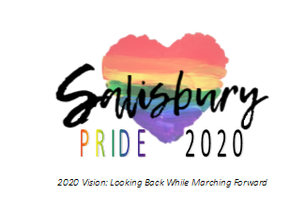
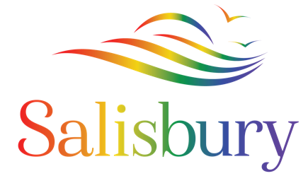

Media Contact: Nicole Hollywood
Phone: 917-854-7408
sbypride@gmail.com
www.SalisburyPrideParade.com

FOR IMMEDIATE RELEASE: 1/22/20
SALISBURY PRIDE ANNOUNCES INTERNATIONAL RECORDING ARTIST AS HEADLINER
Salisbury Pride is excited to announce that famed international recording artist CeCe Peniston will serve as Grand Marshall, and Headliner, of the inaugural Salisbury Pride Parade and Festival scheduled for June 7th, 2020 in downtown Salisbury. Ms. Peniston is the winner of multiple Billboard, ASCAP, and BMI awards and one of the most successful dance club artists in the history of the US Billboard Dance Charts. Ms. Peniston has scored five number top ten hits including Finally and Keep On Walking with Finally serving as the soundtrack of countless drag performances and coming out stories as well as prominently featured as the theme song in the LGBTQ+ cult classic film Adventures of Priscilla Queen of the Desert.
With a five-octave range, CeCe Peniston once performed at Aretha Franklin’s birthday, at the Queen of Soul’s request, and at both of Bill Clinton’s inaugurations. She also made history as the first performer to perform in Africa (before Whitney Houston) after apartheid. She now brings this incomparable talent, which has shared the stage with Andrea Bocelli, to the Eastern Shore.
CeCe Peniston was born in Dayton, Ohio, but was raised in Phoenix, Arizona. She developed her vocal talents in church and sharpened her performing skills in theater. Noted for her beauty, she excelled at pageants becoming crowned Miss Black Arizona in 1989 and Miss Galaxy in 1990.
With a message that uplifts and inspires, and as a staunch LGBTQ+ ally, CeCe Peniston is a popular headliner at major Pride festivals across the globe. Her performance at Salisbury Pride is sponsored by local businessperson Harold Cyr-Townsend.
2020 marks the inaugural year of Salisbury Pride, a joyful celebration of kindness, love, diversity, and inclusion brought to you through a partnership between the City of Salisbury and Salisbury PFLAG. Salisbury Pride is a free, large-scale, outdoor event that includes a parade, a full line-up of on-stage entertainment, vendors, food trucks, a beer and wine garden, roaming acts, a kid’s zone specifically designed for families with young children that includes a drag story hour and crafts, and so much more.
​An exciting roster of performers and speakers is being scheduled. Currently, Ms Peniston is being joined by local drag acts Fheanix and Vicky Ficher as well as transgender writer and rapper Alys. The event master of ceremonies is radio personality and director of the Fenix Youth Project, Amber Green.
The announcement of additional performers will be forthcoming and the speakers will include politicians and activists. Salisbury Pride is looking to include local and regional LGBTQ+ artists and allies in its roster. Candidates interested in performing can complete an interest form on the website www.SalisburyPrideParade.com.

​

