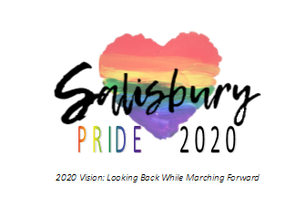
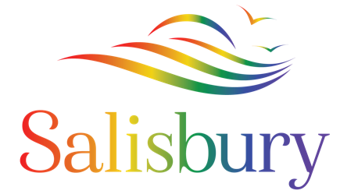
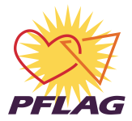

Media Contact: Nicole Hollywood
Phone: 917-854-7408
sbypride@gmail.com
nabuzzetto-more@umes.edu
www.SalisburyPrideParade.com

FOR IMMEDIATE RELEASE
INAUGURAL SALISBURY PRIDE ANNOUNCED FOR JUNE 7TH, 2020
Salisbury PFLAG and the City of Salisbury are pleased to announce the inaugural Salisbury Pride scheduled for June 7th, 2020 in Downtown Salisbury, Maryland. Salisbury Pride represents a joyful celebration of kindness, love, diversity, and inclusion. Salisbury Pride is a free, large-scale, outdoor event that includes a parade, a full line-up of on-stage entertainment, vendors, food trucks, a beer and wine garden, roaming acts, a kid’s zone specifically designed for families with young children that includes a drag story hour and crafts, and so much more.
The mission of Salisbury Pride is “To commemorate our heritage and history, celebrate our community, and advance the equality of LGBTQ+ people.” The goals of the event are to celebrate the City of Salisbury's commitment to increasing visibility of LGBTQ+ people, represent the wide diversity of people in our LGBTQ+ community here on the Shore, build and strengthen alliances with our allies, acknowledge the heritage and legacy of LGBT+ people, and to work towards our full equality and liberation.
The City of Salisbury is the capital of the Eastern Shore and represents the comfortable side of coastal. Commonly referred to as the 'Bury', Salisbury, is proud to be the fastest growing city in Maryland, the first World Kindness City in the United States, as well as the home of the Salisbury Zoo and the host city for the National Folk Festival. Salisbury has made a tremendous commitment in recent years to embrace inclusion of all residents. In 2016, the Salisbury Human Rights Advisory Committee was formed which seeks to both recognize and celebrate the growing diversity of the Salisbury community. The HRAC believes that all community members have the right to be treated with respect, impartiality, and dignity, with equal consideration for race, color, national origin, immigration status, ancestry, gender, sexual orientation, age, religion or disability.
Salisbury PFLAG was founded in 2015. By meeting people where they are and collaborating with others, PFLAG realizes its vision by providing support for families, allies, and people who are LGBTQ; offering education about the unique issues and challenges facing people who are LGBTQ; and engaging in advocacy in the community to change attitudes and create policies and laws that achieve full equality for people who are LGBTQ. Salisbury PFLAG is a chapter of PFLAG National, the largest LGBTQ ally organization in the nation.
Salisbury PFLAG has proudly collaborated in recent years in a number of efforts including the Rainbow Fun Run. Most notably, in 2018 the State of Maryland's first, and currently only, rainbow crosswalk was installed downtown. Additionally, in 2019 Salisbury PFLAG Executive Board Members worked with the City to coordinate Pride On The Plaza where Mayor Jake Day delivered his Proclamation, officially deeming June LGBTQ Pride month in Salisbury, followed by the raising of the Pride flag next to the Obelisk.
​The Parade will start at 11am and the Festival will follow immediately afterwards. Additionally, a number of exciting events will lead up to Salisbury Pride. More information about the Parade and Festival can be found on the Salisbury Pride website at www.SalisburyPrideParade.com. On the website, individuals can also register an individual, or as a group to walk in the parade; entertainers can inquire about performing; vendors can enlist; and people can get involved as volunteers.

