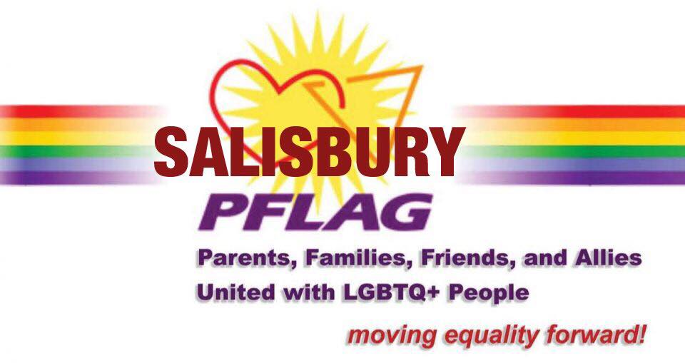
Media Contact: Mark DeLancey
Phone: 603-662-7591
SalisburyPFLAG@outlook.com

NEWS RELEASE
FOR IMMEDIATE RELEASE: 6/16/19
HISTORIC RAINBOW CROSSWALK TO BE REPAINTED ON JUNE 29TH, 2019
The City of Salisbury made history in 2018 by unveiling the first rainbow crosswalk in the State of Maryland. Installed by more than 60 Salisbury PFLAG volunteers with donated paint and materials, the crosswalk represents a celebration of diversity and inclusion acting as a beacon of hope for many residents.
Located between South Division and Market Street in front of the Wicomico Public Library, the crosswalk was a prominent feature during the National Folk Festival. A year later it is in need of refreshing. Accordingly, on June 29th, 2019 Salisbury PFLAG will be repainting the crosswalk and hosting a block party from 9am until 2pm. Snacks, drinks, paint, and supplies will be provided for volunteers and no costs will be incurred by the City.
Cities across the globe have added a touch of LGBTQ visibility and pride by painting rainbow crosswalks on their streets. The first acknowledged rainbow crosswalk was installed in West Hollywood in 2012. Since then, San Francisco, Sydney, Seattle, Key West, Miami, Philadelphia, Toronto, Phoenix, Ottawa, Atlanta, and Denver have all installed permanent crosswalks. The Salisbury rainbow crosswalk remains the only one in Maryland.
The Rainbow Crosswalk repainting will mark the last of the Pride Month activities in Salisbury which have included the Rainbow Fun Run, the Pride on the Plaza proclamation and flag raising by the City, the LGBTQ Family Picnic in City Park, and the LGBTQ History Listening Session. This year marks the 50th anniversary of the Stonewall riots in NYC making it a particularly important and symbolic occasion for the LGBTQ community.
PFLAG is the largest Lesbian, Gay, Bisexual, Transgender, and Questioning/Queer (LGBTQ) ally organization in the nation. PFLAG envisions a world where diversity is celebrated and all people are respected, valued, and affirmed inclusive of their sexual orientation, gender identity, and gender expression. By meeting people where they are and collaborating with others, PFLAG realizes its vision by providing support for families, allies, and people who are LGBTQ; providing education about the unique issues and challenges facing people who are LGBTQ; and providing advocacy in the community to change attitudes and create policies and laws that achieve full equality for people who are LGBTQ. Salisbury PFLAG meetings are open to the public and are held on the second Monday of the month from 6:30 to 8:00pm at the Unitarian Universalist Fellowship located on Old Ocean City Road in Salisbury.

